Zainab Akram 190
BSSE 2D
Programming fundamentals Theory.
Question 1: Write an if/else statement that assigns 0 to x when y is equal to 10. Otherwise, it should assign 1 to x.
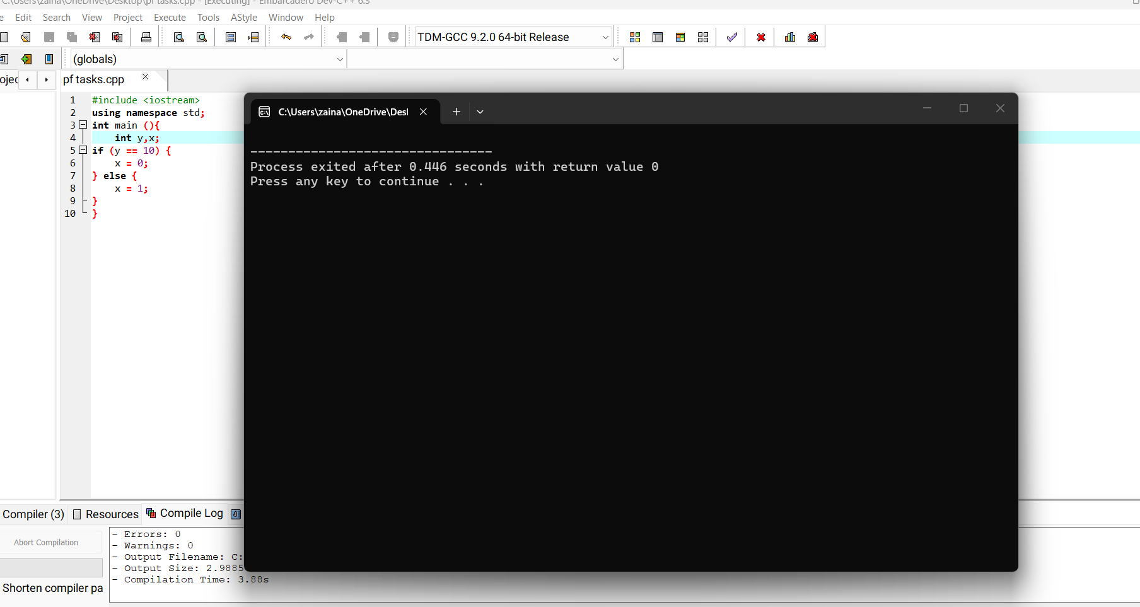
Question 2. Write an if statement that prints the message "The number is valid" if the variable temperature is within the range -50 through 150.
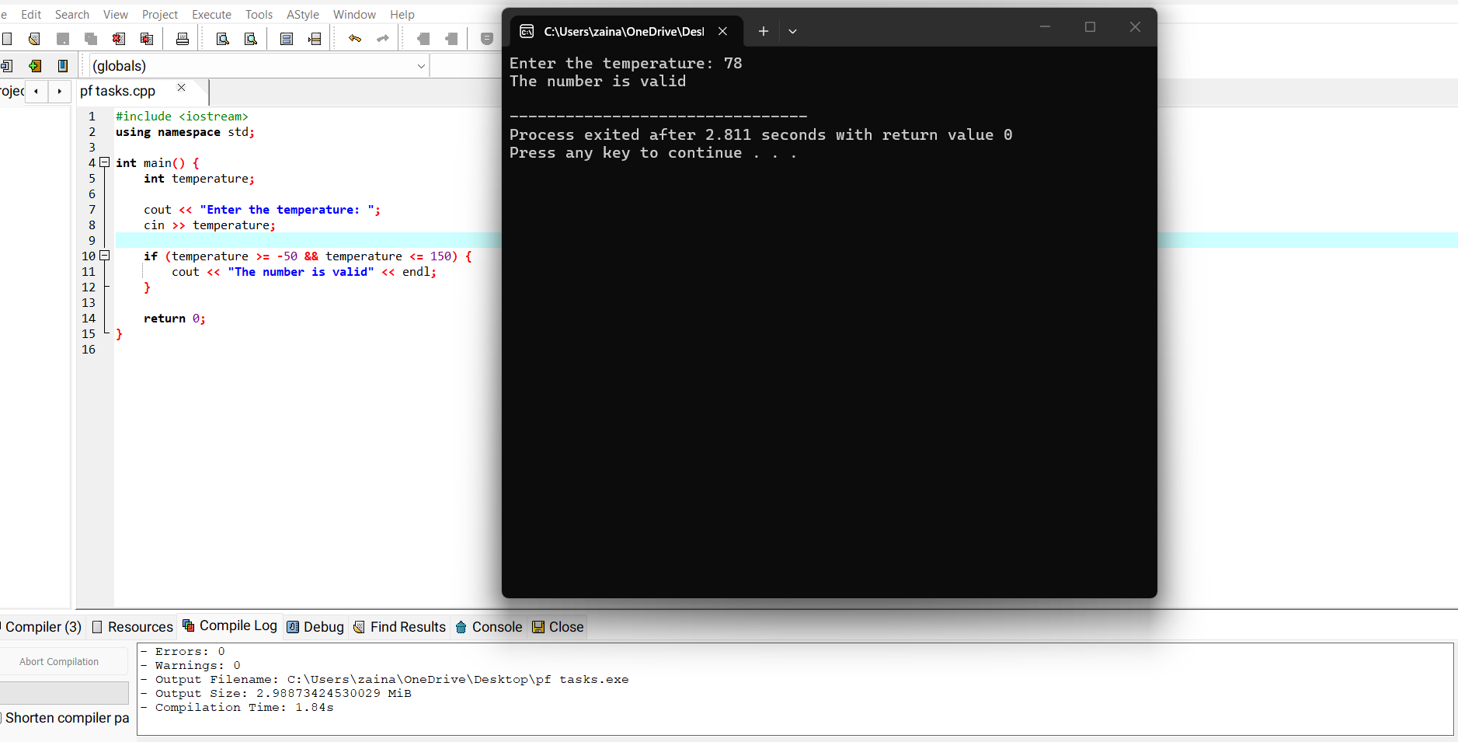
Question 3: Write a program that asks the user to enter two numbers. The program should display which number is the smaller and which is the larger.
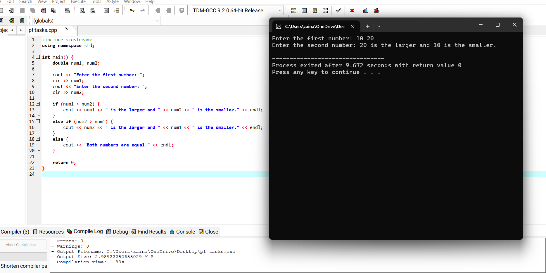
Question 4. Create to variables a and b assigning the same value (eg.10). add 0.2 to a and print which one is larger and which is smaller. Use appropriate data types.
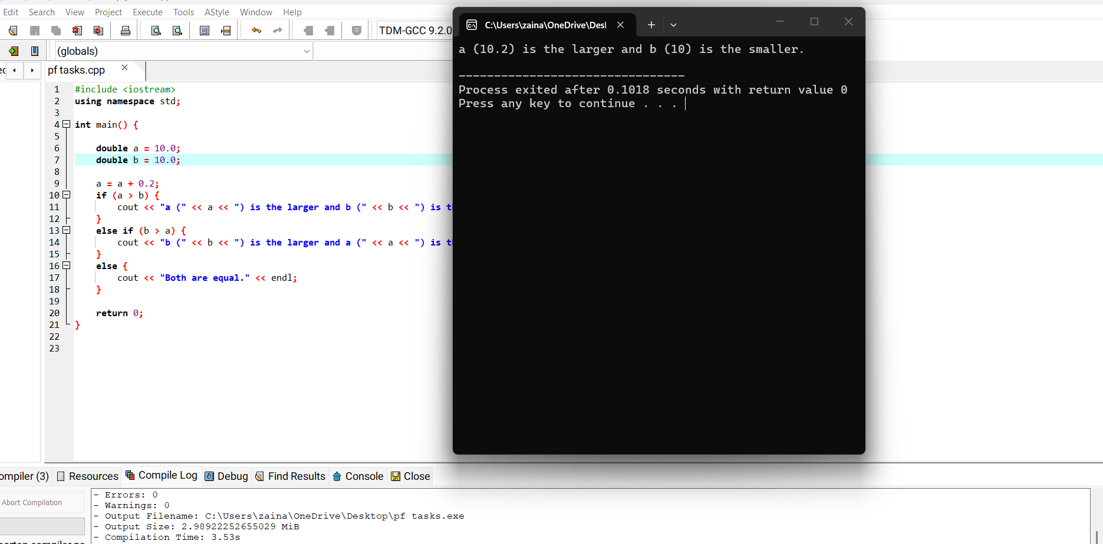
Question5: write a program that takes two numbers from the user and print their division result only if the denominator is not zero. Otherwise print “Division by zero is not possible.”
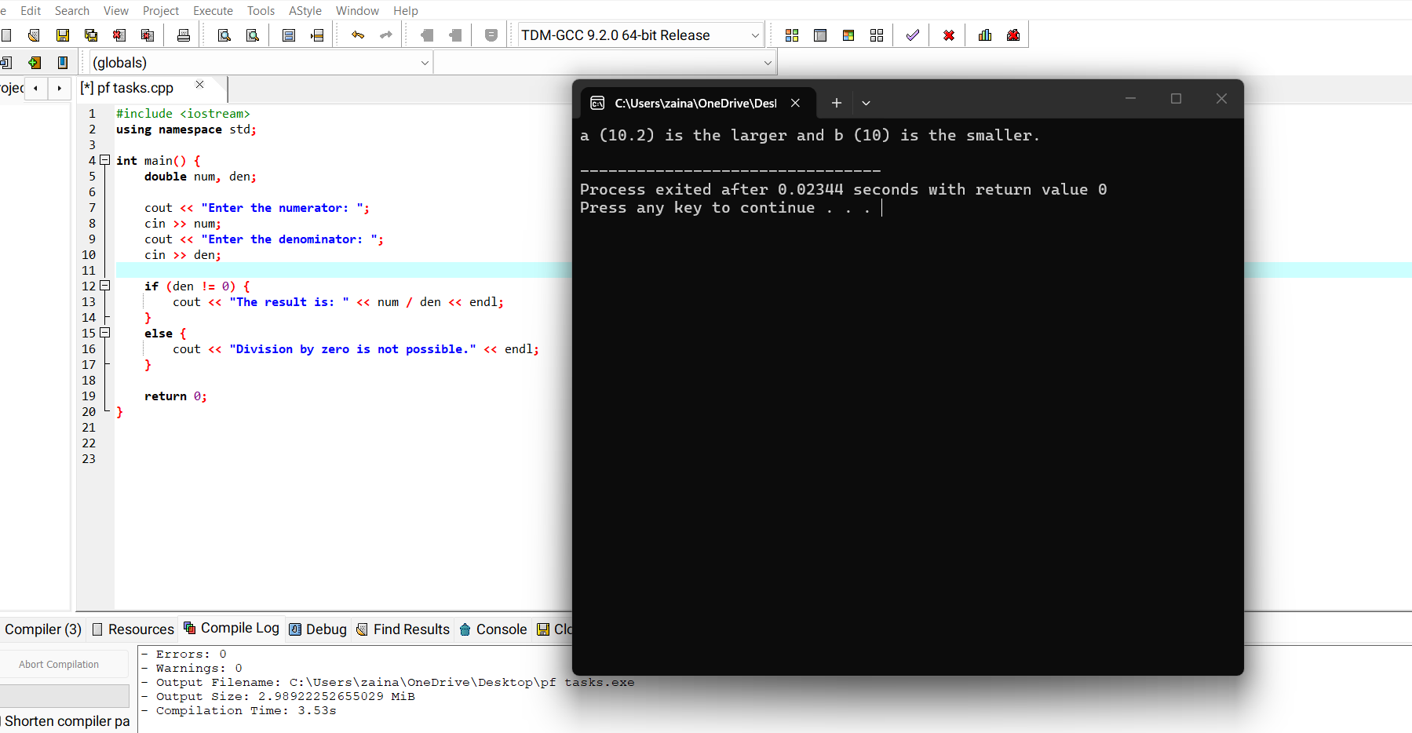
Question 6: Assume the variables a = 2, b = 4, and c = 6. Determine whether each of the following conditions is True or False:
A) a == 4 || b > 2
B) 6 <= c && a 3
C) 1 != b && c != 3
D) a >=-1|| a <= b
E) ! (a > 2)
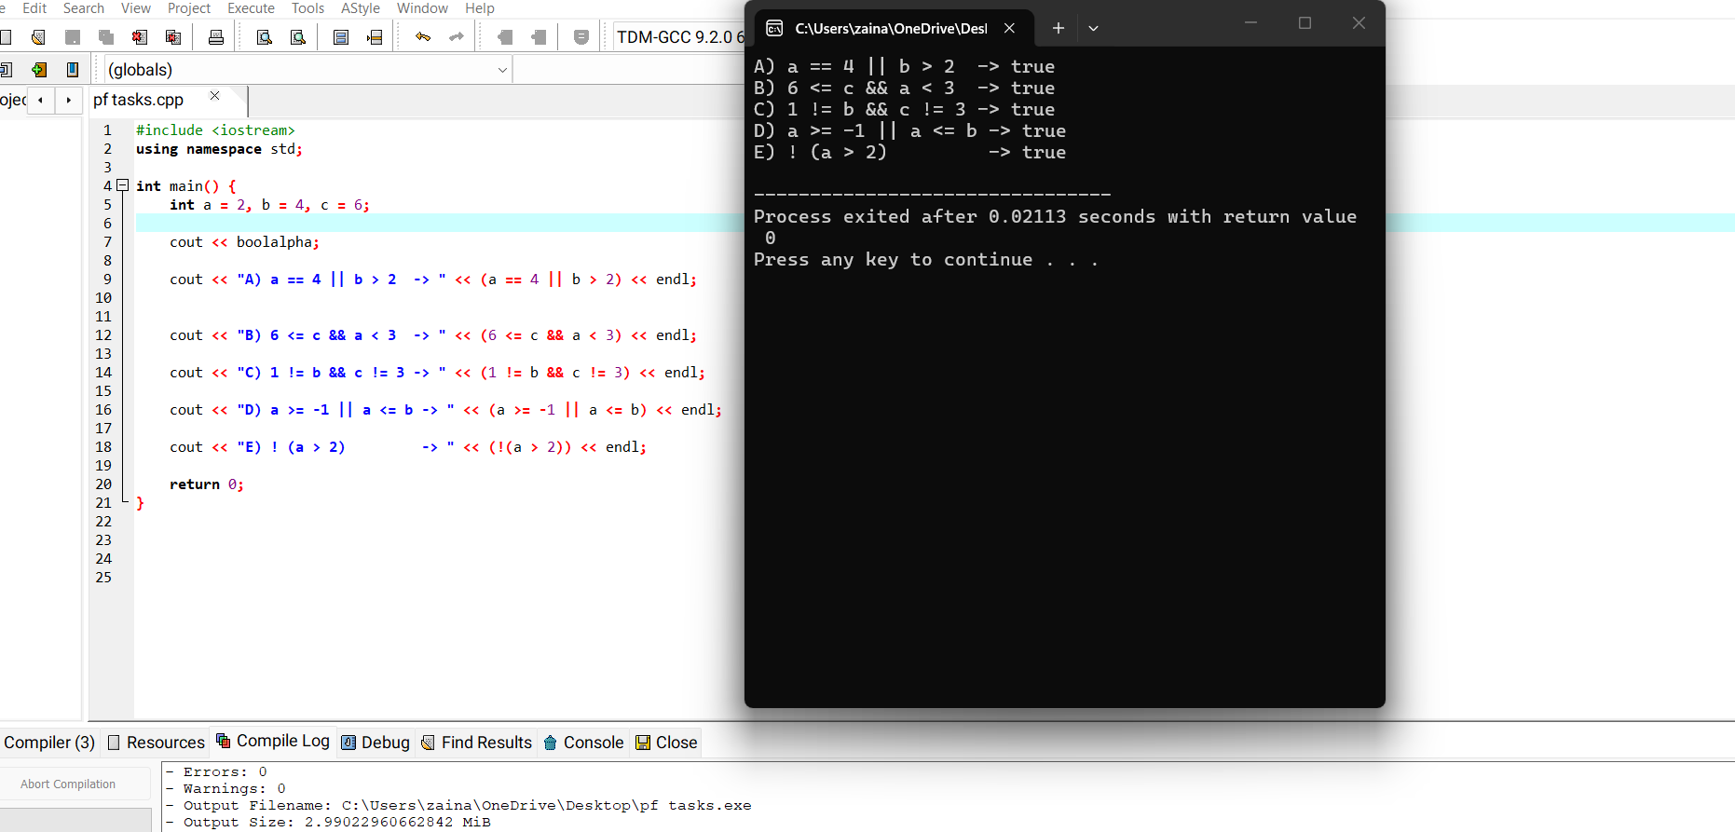
Question 7: Write a program that asks for the time (in minutes) of three runners it took each of them to finish a race. The program should display who came in first, second, and third place.
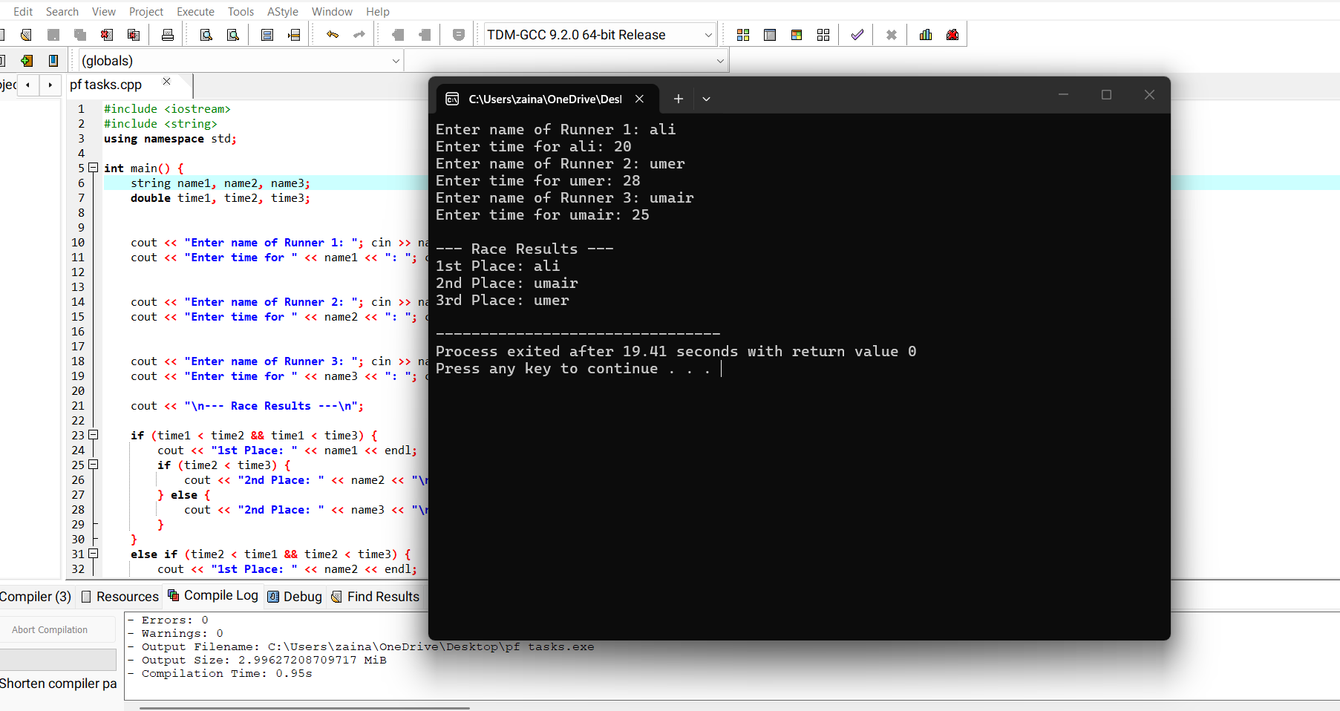
Question 8: Write a program that displays the following menu: Geometry Calculator
1. Calculate the Area of a Circle
2. Calculate the Area of a Rectangle
3. Calculate the Area of a Triangle
Enter your choice (1-3): If the user enters 1, the program should ask for the radius of the circle then display its area. Use the following formula: area = nr2 Use 3.14159 for n and the radius of the circle for r.
If the user enters 2, the program should ask for the length and width of the rectangle, then display the rectangle's area. Use the following formula: area = length* width If the user enters 3, the program should ask for the length of the triangle's base and its height, then display its area. Use the following formula: area = base * height* .5
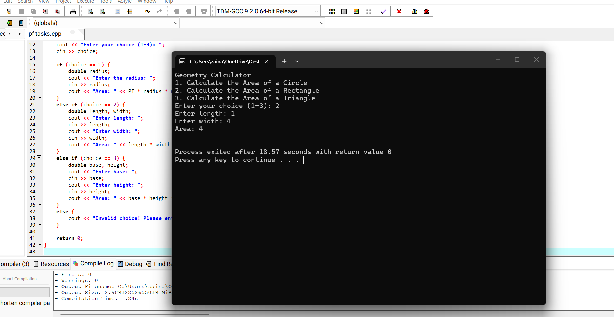
Question 10: If you know the amount of mass that an object has, you can calculate its weight, in newtons, with the following formula: Weight = mass x 9.8 Write a program that asks the user to enter an object's mass, then calculates and displays its weight. If the object weighs more than 1,000 newtons, display a message indicating that it is too heavy. If the object weighs less than 10 newtons, display a message indicating that the object is too light.
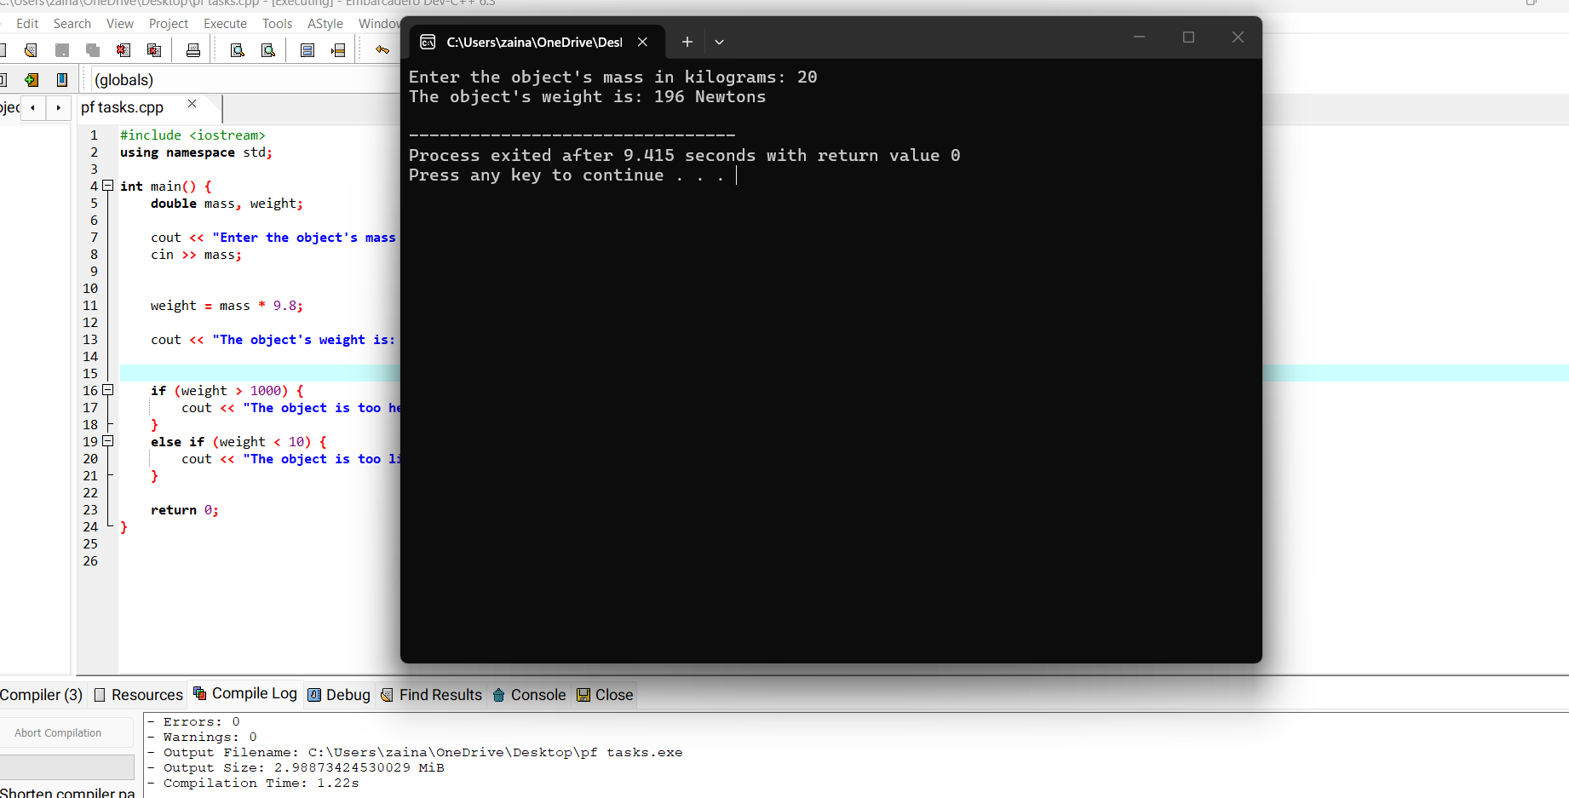
Question 11. Write an if statement that performs the following logic: if the variable sales is greater than 50,000, then add 0.25 of the sales variable, and 250 as a bonus. Print the sales.

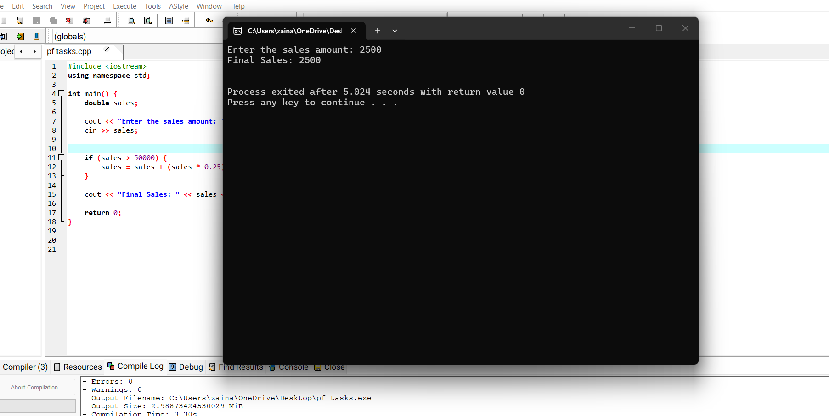
Question 12. Write a program that determines whether a user qualifies for a special loan based on their annual income and their job stability (years at current employment).To qualify for the loan, the applicant must meet both of the following requirements:
- Income Requirement: The annual income must be at least $35,000.00.
- Employment Requirement: The applicant must have been employed at their current job for more than 5 years.

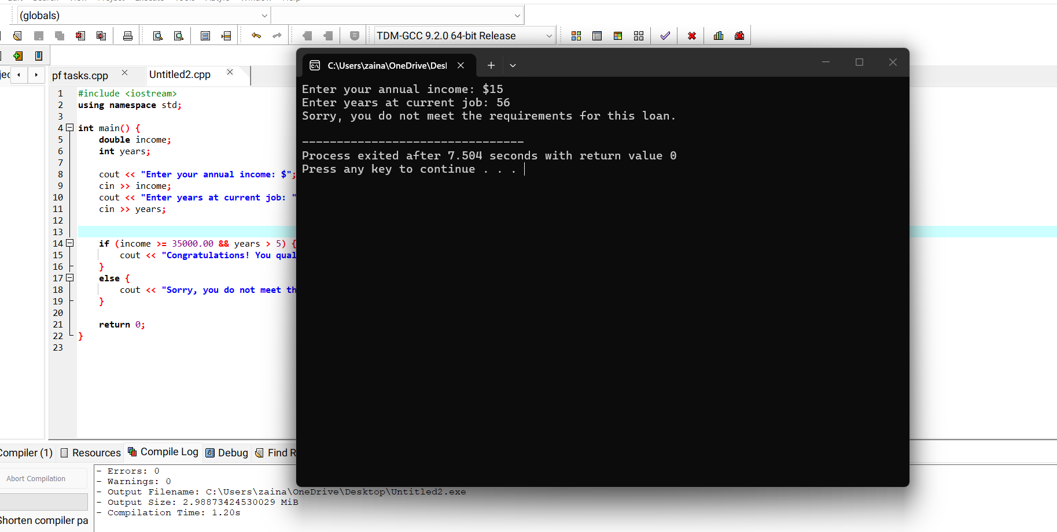
Question 13. Ask user which TV model he wants to purchase and display the features of the respective model .
Model 300 has features Picture-in-a-picture, Stereo sound, and Remote control
Model 200 Stereo sound and Remote control
Model 100 Remote control only
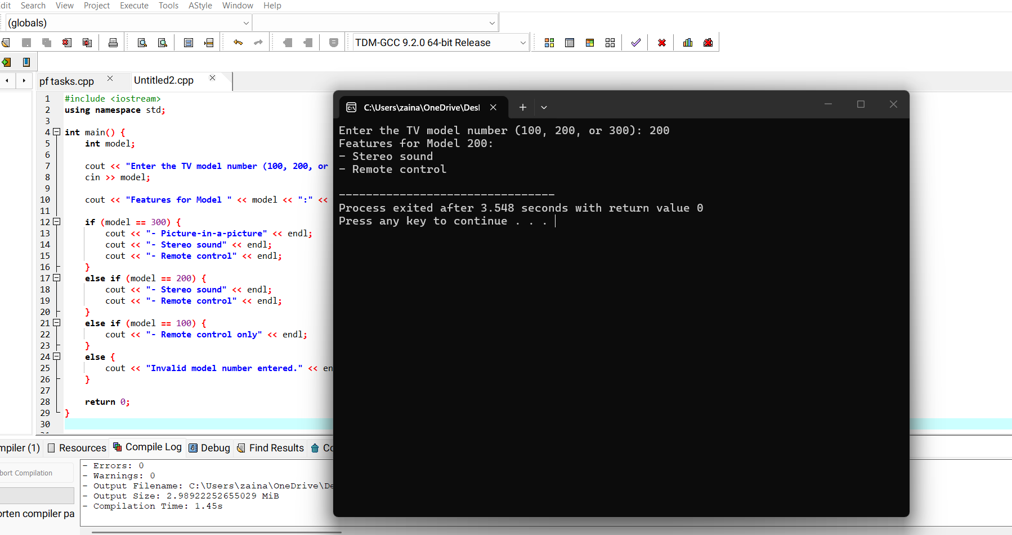
Question 14: The date June 10, 1960 is special because when we write it in the following format, the
month times the day equals the year.
6/10/60
Write a program that asks the user to enter a month (in numeric form), a day, and a two-digit year. The program should then determine whether the month times the day is equal to the year. If so, it should display a message saying the date is magic.
Otherwise, it should display a message saying the date is not magic.
Sample output:
Input: Month = 2, Day = 5, Year = 20
Calculation: 2 * 5 = 10(10 is not equal to 20)
Result: NOT MAGIC.

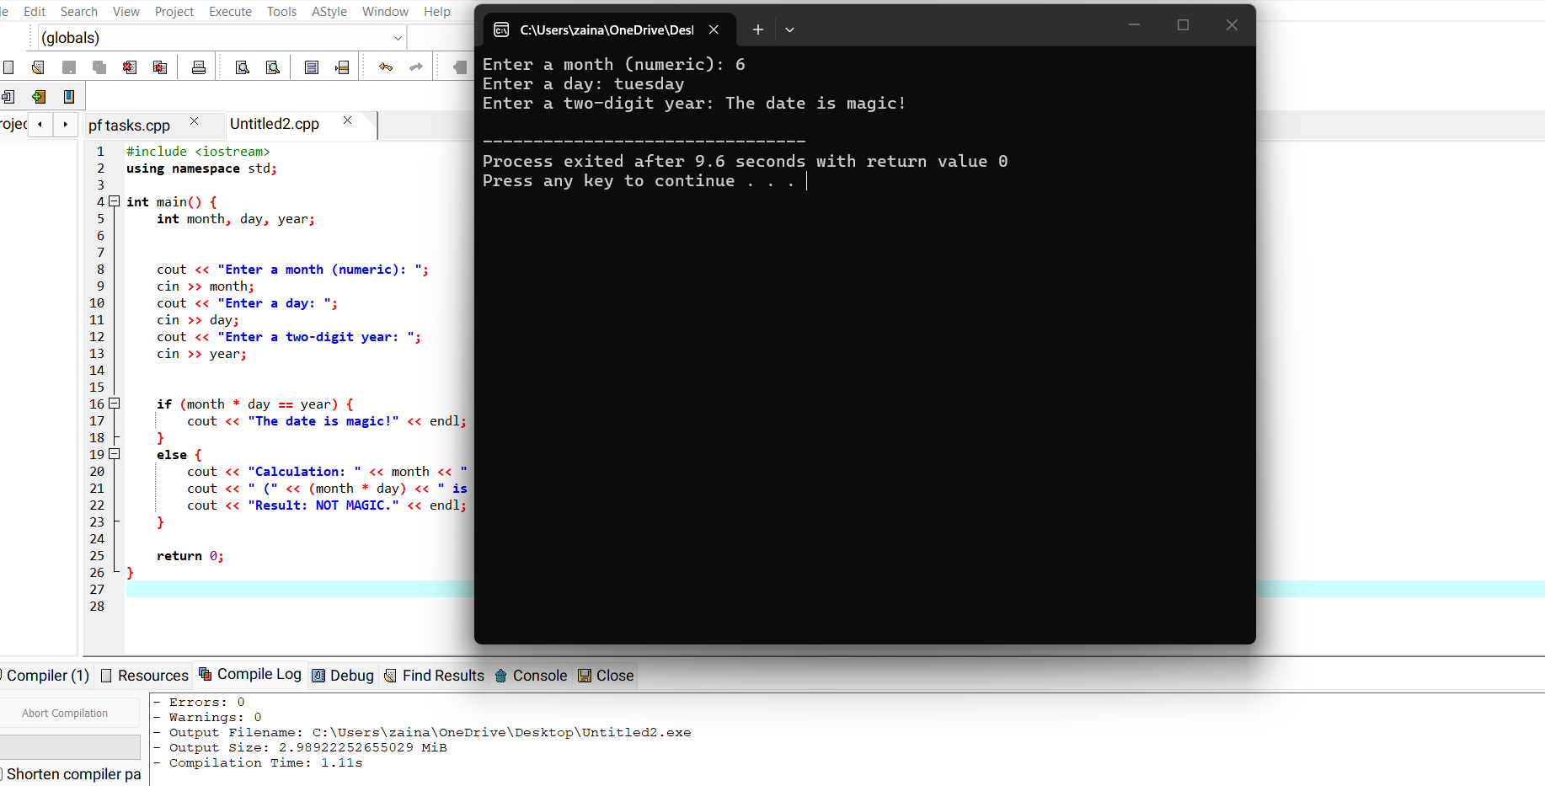
Question 15: Using the following chart, write an if/else if statement that assigns .10, .15, or .20
to commission, depending on the value in sales entered by the user.
Sales Commission Rate
Up to $10,000 10%
$10,000 to $15,000 15%
Over $15,000 20%
